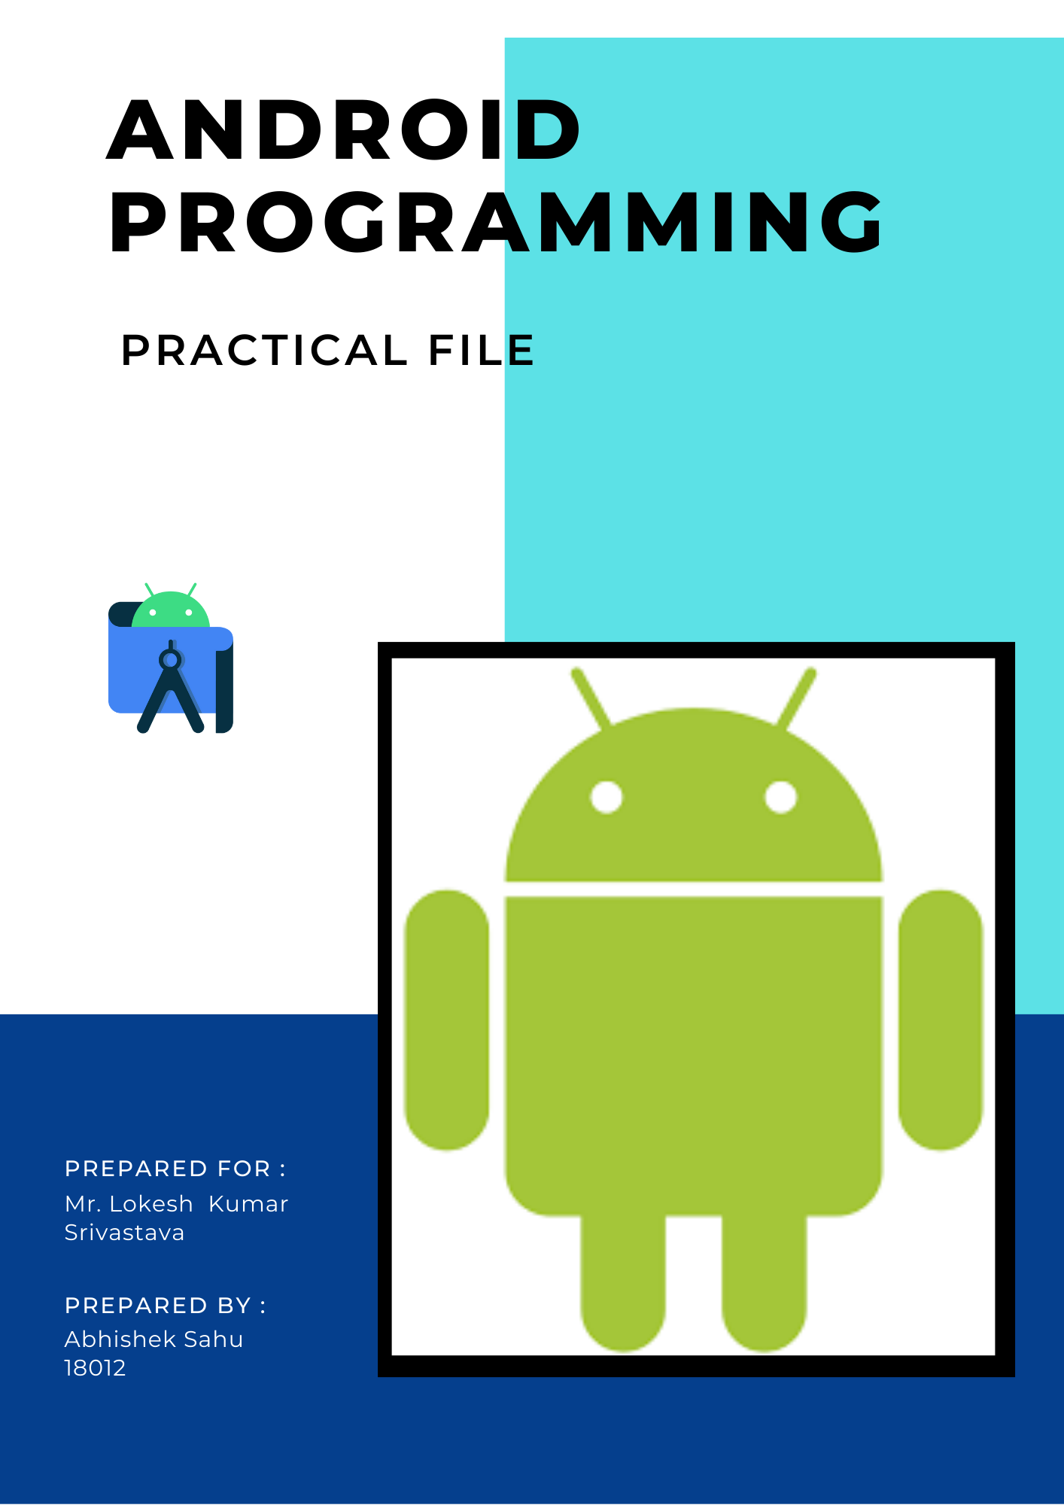

**INDEX**

|  |  |
| --- | --- |
| **Serial No.** | **Practical** |
| 1 | Create “Hello World” application that will display “Hello World” in the middle of the screen in the emulator. Also display “Hello World” in the  middle of the screen in the android phone. |
| 2 | Create an application to display various android activity lifecycle phases. |
| 3 | Create an application with first activity with an editText and send button. On click of send button,  make use of explicit intent to send text to second activity and display there in text view. |
| 4 | Create an application with first activity with an editText and send button. On click of send button, make use of implicit intent that uses a SEND ACTION and let user select app from app chooser  and navigate to that application. |
| 5 | Create spinner with strings taken from resource  folder (res >> value folder) and on changing the spinner value, Image will change. |
| 6 | Create a menu with 5 options and selected option should appear in text box in upper case. |

|  |  |
| --- | --- |
| **Serial No.** | **Practical** |
| 7 | Create a radio button group with radio button of all courses in your college and on selecting a particular course, teacher-in- charge of that course should appear  at the bottom of the screen. |
| 8 | Create a list of all courses in your college and on selecting a particular course parent department and theteacher-in-charge of that department should appear at  the bottom of the screen. |
| 9 | 1. Create an application with three buttons (with different color names) vertically aligned, on selecting abutton color of the screen will change. 2. Create an application with three buttons horizontallyaligned, on selecting a button color of the screen will   change. |
| 10 | Create a Login application (check username and password). On successful login, pop up the message.  ("Welcome username") |
| 11 | Create a login application as above, on successful login redirect to another activity with logout button. On clickof logout button a dialog appears with OK and CANCEL button. On OK button click go to login activity and on  CANCEL stay at same activity. |
| 12 | Create an application to Create, Insert, update and Delete operation on the database. |

## **Practical 1: Create “Hello World” application that will display “Hello World” in the middle of the screen in the emulator. Also display “Hello World” inthe middle of the screen in the android phone.**

Code:

## activity_main.xml

<?xml version="1.0" encoding="utf-8"?>

<androidx.constraintlayout.widget.ConstraintLayout xmlns:andr[oid="ht](http://schemas.android.com/apk/res/android)tp://[schemas.android.com/apk/res/android"](http://schemas.android.com/apk/res/android)

xmlns:a[pp="ht](http://schemas.android.com/apk/res-auto)tp:[//](http://schemas.android.com/apk/res-auto)s[chemas.android.com/apk/res-auto"](http://schemas.android.com/apk/res-auto) xmlns:tools[="ht](http://schemas.android.com/tools)t[p://](http://schemas.android.com/tools)s[chemas.android.com/tools](http://schemas.android.com/tools)" android:layout_width="match_parent" android:layout_height="match_parent" tools:context=".MainActivity">

<TextView android:layout_width="wrap_content" android:layout_height="wrap_content" android:text="Hello World!" android:textSize="50sp"

app:layout_constraintBottom_toBottomOf="parent" app:layout_constraintLeft_toLeftOf="parent" app:layout_constraintRight_toRightOf="parent" app:layout_constraintTop_toTopOf="parent" />

</androidx.constraintlayout.widget.ConstraintLayout>

## MainActivity.java

package com.example.project1;

import androidx.appcompat.app.AppCompatActivity; import android.os.Bundle;

public class MainActivity extends AppCompatActivity { @Override

protected void onCreate(Bundle savedInstanceState) { super.onCreate(savedInstanceState); setContentView(R.layout.activity_main);

}

}

OUTPUT –

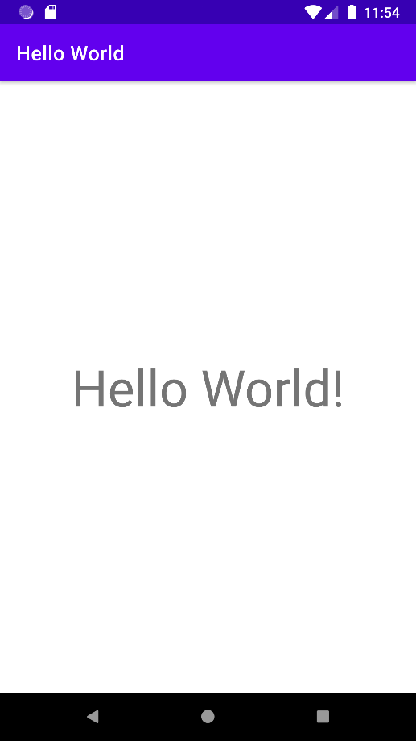

**Practical 2: Create an application to display various android activitylifecycle phases.**

Code:

activity_main.xml

<?xml version="1.0" encoding="utf-8"?>

<androidx.constraintlayout.widget.ConstraintLayout xmlns:andr[oid="ht](http://schemas.android.com/apk/res/android)tp://[schemas.android.com/apk/res/android"](http://schemas.android.com/apk/res/android)

xmlns:a[pp="ht](http://schemas.android.com/apk/res-auto)tp:[//](http://schemas.android.com/apk/res-auto)s[chemas.android.com/apk/res-auto"](http://schemas.android.com/apk/res-auto) xmlns:tools[="ht](http://schemas.android.com/tools)t[p://](http://schemas.android.com/tools)s[chemas.android.com/tools](http://schemas.android.com/tools)" android:layout_width="match_parent" android:layout_height="match_parent" tools:context=".MainActivity">

<TextView android:layout_width="wrap_content" android:layout_height="wrap_content" android:text="Hello World!"

app:layout_constraintBottom_toBottomOf="parent" app:layout_constraintLeft_toLeftOf="parent" app:layout_constraintRight_toRightOf="parent" app:layout_constraintTop_toTopOf="parent" />

</androidx.constraintlayout.widget.ConstraintLayout>

## MainActivity.java

package com.example.program2;

import android.app.Activity; import android.os.Bundle; import android.util.Log;

public class MainActivity extends Activity { @Override

protected void onCreate(Bundle savedInstanceState) { super.onCreate(savedInstanceState); setContentView(R.layout.activity_main); Log.d("lifecycle","onCreate invoked");

}

@Override

protected void onStart() {

super.onStart(); Log.d("lifecycle","onStart invoked");

}

@Override

protected void onResume() { super.onResume(); Log.d("lifecycle","onResume invoked");

}

@Override

protected void onPause() {

super.onPause(); Log.d("lifecycle","onPause invoked");

}

@Override

protected void onStop() { super.onStop(); Log.d("lifecycle","onStop invoked");

}

@Override

protected void onRestart() { super.onRestart(); Log.d("lifecycle","onRestart invoked");

}

@Override

protected void onDestroy() { super.onDestroy(); Log.d("lifecycle","onDestroy invoked");

}

}

OUTPUT –

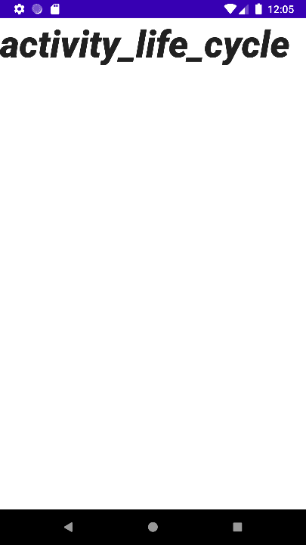

LOGCAT –

2022-02-19 12:05:08.979 8956-8956/com.example.program2 D/lifecycle: onStart invoked

2022-02-19 12:05:08.984 8956-8956/com.example.program2 D/lifecycle: onResume invoked

2022-02-19 12:05:09.064 8956-8985/com.example.program2 D/EGL_emulation: eglMakeCurrent: 0xdec85120: ver 2 0 (tinfo 0xdec83290)

2022-02-19 12:05:12.533 8956-8956/com.example.program2 D/lifecycle: onPause invoked

2022-02-19 12:05:12.552 8956-8985/com.example.program2 D/EGL_emulation: eglMakeCurrent: 0xdec85120: ver 2 0 (tinfo 0xdec83290)

2022-02-19 12:05:12.555 8956-8956/com.example.program2 D/lifecycle: onStop invoked

2022-02-19 12:05:17.867 8956-8956/com.example.program2 D/lifecycle: onRestart invoked

2022-02-19 12:05:17.867 8956-8956/com.example.program2 D/lifecycle: onStart invoked

2022-02-19 12:05:17.869 8956-8956/com.example.program2 D/lifecycle: onResume invoked

2022-02-19 12:05:17.945 8956-8985/com.example.program2 D/EGL_emulation: eglMakeCurrent: 0xdec85120: ver 2 0 (tinfo 0xdec83290)

2022-02-19 12:05:23.218 8956-8956/com.example.program2 D/lifecycle: onPause invoked

2022-02-19 12:05:23.232 8956-8985/com.example.program2 D/EGL_emulation: eglMakeCurrent: 0xdec85120: ver 2 0 (tinfo 0xdec83290)

2022-02-19 12:05:23.236 8956-8956/com.example.program2 D/lifecycle: onStop invoked

2022-02-19 12:05:24.963 8956-8956/com.example.program2 D/lifecycle: onDestroy invoked

## **Practical 3: Create an application with first activity with an editText and send button. On click of send button, make use of explicit intent to send textto second activity and display there in text view.**

Code:

## activity_main.xml

<?xml version="1.0" encoding="utf-8"?>

<RelativeLayout xmlns:andr[oid="ht](http://schemas.android.com/apk/res/android)tp://[schemas.android.com/apk/res/android"](http://schemas.android.com/apk/res/android) xmlns:a[pp="ht](http://schemas.android.com/apk/res-auto)tp:[//](http://schemas.android.com/apk/res-auto)s[chemas.android.com/apk/res-auto"](http://schemas.android.com/apk/res-auto) xmlns:tools[="ht](http://schemas.android.com/tools)t[p://](http://schemas.android.com/tools)s[chemas.android.com/tools](http://schemas.android.com/tools)" android:layout_width="match_parent" android:layout_height="match_parent" tools:context=".MainActivity">

<EditText android:id="@+id/send_text_id" android:layout_width="300dp" android:layout_height="wrap_content" android:layout_marginLeft="40dp" android:layout_marginTop="20dp" android:hint="Input" android:textSize="25dp" android:textStyle="bold" />

<Button android:id="@+id/send_button_id" android:layout_width="wrap_content"

android:layout_height="40dp" android:text="send" android:textStyle="bold" android:layout_marginTop="150dp" android:layout_marginLeft="150dp"/>

</RelativeLayout>

## MainActivity.java

package com.example.program3;

import android.content.Intent;

import androidx.appcompat.app.AppCompatActivity; import android.os.Bundle;

import android.view.View; import android.widget.Button; import android.widget.EditText;

public class MainActivity extends AppCompatActivity { Button send_button;

EditText send_text; @Override

protected void onCreate(Bundle savedInstanceState)

{

super.onCreate(savedInstanceState); setContentView(R.layout.activity_main);

send_button = (Button)findViewById(R.id.send_button_id); send_text = (EditText)findViewById(R.id.send_text_id);

send_button.setOnClickListener(new View.OnClickListener() { @Override

public void onClick(View v)

{

String str = send_text.getText().toString();

Intent intent = new Intent(getApplicationContext(), MainActivity2.class); intent.putExtra("message_key", str);

startActivity(intent);

}

});

}

}

# activity_second.xml

<?xml version="1.0" encoding="utf-8"?>

<RelativeLayout xmlns:android="<http://schemas.android.com/apk/res/android>" xmlns:app="[http://schemas.android.com/apk/res-auto"](http://schemas.android.com/apk/res-auto) xmlns:tools="<http://schemas.android.com/tools>" android:layout_width="match_parent" android:layout_height="match_parent"

tools:context=".MainActivity2">

<TextView android:id="@+id/received_value_id" android:layout_width="300dp" android:layout_height="50dp" android:textStyle="bold" android:textSize="40dp" android:layout_marginTop="20dp"

android:layout_marginLeft="40dp"/>

</RelativeLayout>

# SecondActivity.java

package com.example.program3; import android.content.Intent;

import androidx.appcompat.app.AppCompatActivity; import android.os.Bundle;

import android.widget.TextView;

public class MainActivity2 extends AppCompatActivity { TextView receiver_msg;

@Override

protected void onCreate(Bundle savedInstanceState)

{

super.onCreate(savedInstanceState); setContentView(R.layout.activity_main2);

receiver_msg = (TextView)findViewById(R.id.received_value_id); Intent intent = getIntent();

String str = intent.getStringExtra("message_key"); receiver_msg.setText(str);

}

}

OUTPUT –

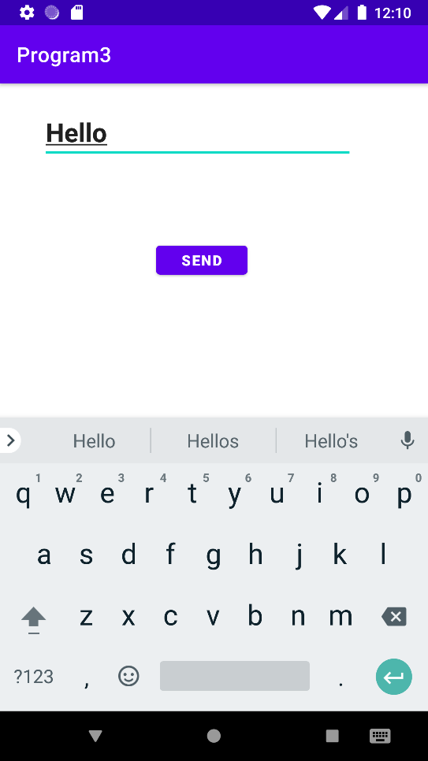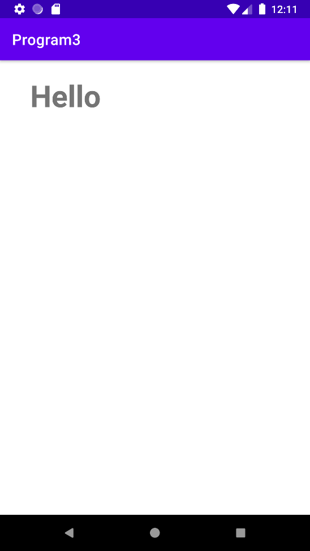

**Practical 4: Create an application with first activity with an editTextand send button. On click of send button, make use of implicit intent that uses aSEND ACTION and let user select app from app chooser and navigate to that application.**

Code:

activity_main.xml

<RelativeLayout xmlns:andr[oid="ht](http://schemas.android.com/apk/res/android)tp://[schemas.android.com/apk/res/android"](http://schemas.android.com/apk/res/android) xmlns:tools[="ht](http://schemas.android.com/tools)t[p://](http://schemas.android.com/tools)s[chemas.android.com/tools](http://schemas.android.com/tools)" android:layout_width="match_parent" android:layout_height="match_parent" android:paddingLeft="@dimen/activity_horizontal_margin" android:paddingRight="@dimen/activity_horizontal_margin" android:paddingTop="@dimen/activity_vertical_margin" android:paddingBottom="@dimen/activity_vertical_margin" tools:context=".MainActivity">

<EditText android:id="@+id/editText1"

android:layout_width="wrap_content" android:layout_height="wrap_content" android:layout_alignParentRight="true" android:layout_alignParentTop="true" android:layout_marginRight="22dp" android:layout_marginTop="16dp"

/>

<EditText android:id="@+id/editText2"

android:layout_width="wrap_content" android:layout_height="wrap_content" android:layout_alignLeft="@+id/editText1" android:layout_below="@+id/editText1" android:layout_marginTop="20dp"

>

<requestFocus />

</EditText>

<EditText android:id="@+id/editText3"

android:layout_width="wrap_content" android:layout_height="wrap_content" android:layout_alignLeft="@+id/editText2" android:layout_below="@+id/editText2" android:layout_marginTop="30dp" android:inputType="textMultiLine" />

<TextView android:id="@+id/textView1"

android:layout_width="wrap_content" android:layout_height="wrap_content" android:layout_alignBaseline="@+id/editText1" android:layout_alignBottom="@+id/editText1"

android:layout_alignParentLeft="true" android:text="To:" />

<TextView android:id="@+id/textView2"

android:layout_width="wrap_content" android:layout_height="wrap_content" android:layout_alignBaseline="@+id/editText2" android:layout_alignBottom="@+id/editText2" android:layout_alignParentLeft="true" android:text="Subject:" />

<TextView android:id="@+id/textView3"

android:layout_width="wrap_content" android:layout_height="wrap_content" android:layout_alignBaseline="@+id/editText3" android:layout_alignBottom="@+id/editText3" android:layout_alignParentLeft="true" android:text="Message:" />

<Button android:id="@+id/button1"

android:layout_width="wrap_content" android:layout_height="wrap_content" android:layout_alignLeft="@+id/editText3" android:layout_below="@+id/editText3"

android:layout_marginLeft="70dp" android:layout_marginTop="25dp" android:text="Send" />

</RelativeLayout>

## MainActivity.java

package com.example.program4; import android.app.Activity; import android.content.Intent;

import androidx.appcompat.app.AppCompatActivity; import android.os.Bundle;

import android.view.View; import android.widget.EditText; import android.view.Menu; import android.view.MenuItem; import android.widget.Button;

public class MainActivity extends Activity {

EditText editTextTo,editTextSubject,editTextMessage; Button send;

@Override

protected void onCreate(Bundle savedInstanceState) { super.onCreate(savedInstanceState); setContentView(R.layout.activity_main); editTextTo=(EditText)findViewById(R.id.editText1); editTextSubject=(EditText)findViewById(R.id.editText2); editTextMessage=(EditText)findViewById(R.id.editText3);

send=(Button)findViewById(R.id.button1); send.setOnClickListener(new View.OnClickListener(){

@Override

public void onClick(View arg0) {

String to=editTextTo.getText().toString();

String subject=editTextSubject.getText().toString(); String message=editTextMessage.getText().toString(); Intent email = new Intent(Intent.ACTION_SEND); email.putExtra(Intent.EXTRA_EMAIL, new String[]{ to}); email.putExtra(Intent.EXTRA_SUBJECT, subject); email.putExtra(Intent.EXTRA_TEXT, message); email.setType("message/rfc822");

startActivity(Intent.createChooser(email, "Choose an Email client :"));

}

});

}

@Override

public boolean onCreateOptionsMenu(Menu menu) { getMenuInflater().inflate(R.menu.example_menu, menu); return true;

}

@Override

public boolean onOptionsItemSelected(MenuItem item) { int id = item.getItemId();

if (id == R.id.actions) { return true;

}

return super.onOptionsItemSelected(item);

}

}

OUTPUT –

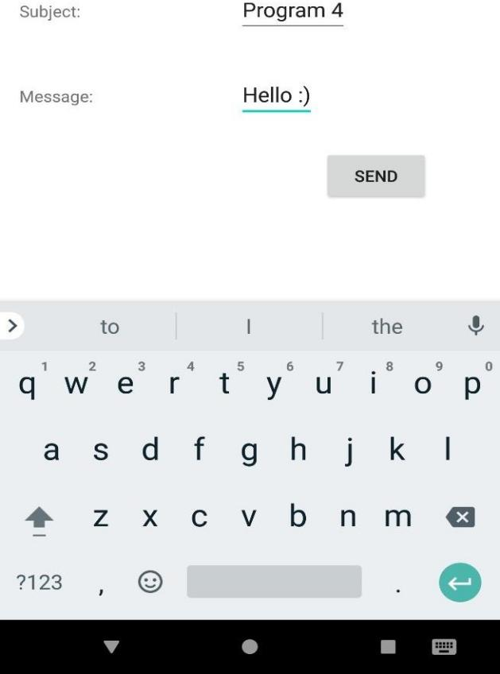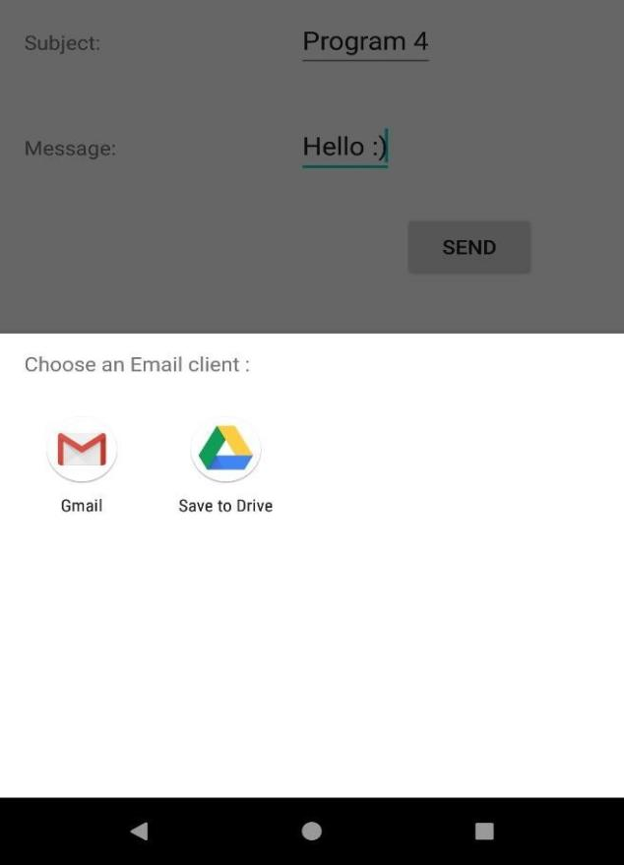

**Practical 5: Create spinner with strings taken from resource folder (res**

## **>> value folder) and on changing the spinner value, Image will change.** Code:

Activity_main.xml

<?xml version="1.0" encoding="utf-8"?>

<androidx.constraintlayout.widget.ConstraintLayout xmlns:andr[oid="ht](http://schemas.android.com/apk/res/android)tp://[schemas.android.com/apk/res/android"](http://schemas.android.com/apk/res/android) xmlns:a[pp="ht](http://schemas.android.com/apk/res-auto)tp:[//](http://schemas.android.com/apk/res-auto)s[chemas.android.com/apk/res-auto"](http://schemas.android.com/apk/res-auto) xmlns:tools[="ht](http://schemas.android.com/tools)t[p://](http://schemas.android.com/tools)s[chemas.android.com/tools](http://schemas.android.com/tools)" android:layout_width="match_parent" android:layout_height="match_parent" tools:context=".MainActivity"> <Spinner android:id="@+id/spinner"

android:layout_width="0dp" android:layout_height="wrap_content" android:layout_marginStart="8dp" android:layout_marginLeft="8dp" android:layout_marginTop="16dp" android:layout_marginEnd="8dp" android:layout_marginRight="8dp" app:layout_constraintEnd_toEndOf="parent" app:layout_constraintStart_toStartOf="parent" app:layout_constraintTop_toTopOf="parent" /><ImageView android:id="@+id/image"

android:layout_width="332dp" android:layout_height="323dp"

app:layout_constraintBottom_toBottomOf="parent" app:layout_constraintEnd_toEndOf="parent" app:layout_constraintStart_toStartOf="parent" app:layout_constraintTop_toTopOf="@+id/spinner" app:layout_constraintVertical_bias="0.479" />

</androidx.constraintlayout.widget.ConstraintLayout>

## MainActivity.java

package com.example.p5;

import androidx.appcompat.app.AppCompatActivity; import android.os.Bundle; import android.view.View; import android.widget.AdapterView;

import android.widget.ArrayAdapter; import android.widget.ImageView; import android.widget.Spinner;

public class MainActivity extends AppCompatActivity { private Spinner spinner; private ImageView image;

@Override

protected void onCreate(Bundle savedInstanceState) { super.onCreate(savedInstanceState); setContentView(R.layout.activity_main);

spinner=findViewById(R.id.spinner); image=findViewById(R.id.image);

String [] birds={"Select One","s1","s2","s3","s4"};

ArrayAdapter<String>adapter=new ArrayAdapter<String>(this,android.R.layout.simple_spinner_dropdown_item,birds);

spinner.setAdapter(adapter);

spinner.setOnItemSelectedListener(new AdapterView.OnItemSelectedListener() { @Override

public void onItemSelected(AdapterView<?> parent, View view, int position, long id) { switch (position){ case 1:

image.setImageResource(R.drawable.a); break; case 2: image.setImageResource(R.drawable.b); break; case 3:

image.setImageResource(R.drawable.c); break; case 4: image.setImageResource(R.drawable.d); break; } }

} }

## Output –

@Override public void onNothingSelected(AdapterView<?> parent)

{ } });

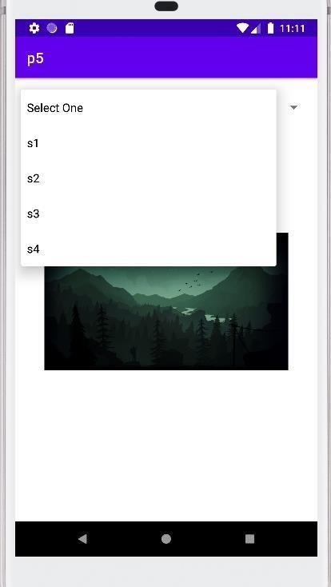 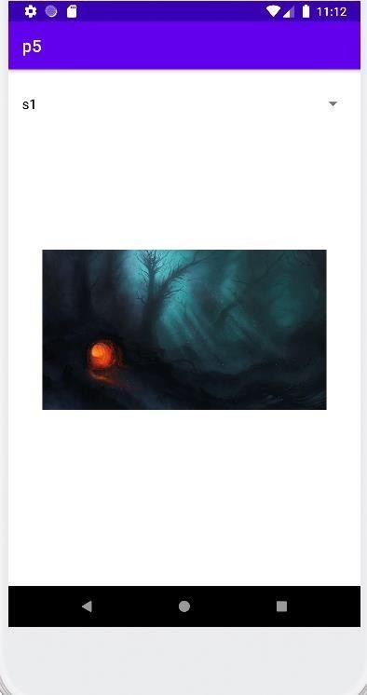

## **Practical 6: Create a menu with 5 options and selected option shouldappear intext box in upper case.**

Code:

## Activity_main.xml

*<?*xml version="1.0" encoding="utf-8"*?>*

<androidx.constraintlayout.widget.ConstraintLayout xmlns:android="<http://schemas.android.com/apk/res/android>"

xmlns:app="<http://schemas.android.com/apk/res-auto>" xmlns:tools="<http://schemas.android.com/tools>"

android:layout_width="match_parent" android:layout_height="match_parent" tools:context=".MainActivity">

<RelativeLayout android:layout_width="match_parent" android:layout_height="match_parent" android:layout_margin="80dp" app:layout_constraintBottom_toBottomOf="parent" app:layout_constraintLeft_toLeftOf="parent" app:layout_constraintRight_toRightOf="parent" app:layout_constraintTop_toTopOf="parent">

<EditText android:layout_width="match_parent" android:layout_height="wrap_content" android:id="@+id/etMenuItem" android:layout_centerInParent="true"

android:hint="Select an Option from the Menu" android:textAlignment="center" android:gravity="center_horizontal" />

</RelativeLayout>

</androidx.constraintlayout.widget.ConstraintLayout>

## MainActivity.java

package com.example.p6; importandroidx.appcompat.app.AppCompatActivity; import android.os.Bundle;

import android.view.Menu;

import android.view.MenuInflater;import android.view.MenuItem; import android.widget.EditText;

public class MainActivity extends AppCompatActivity { private EditText etMenuIte

@Override

protected void onCreate(Bundle savedInstanceState) { super.onCreate(savedInstanceState); setContentView(R.layout.*activity_main*); etMenuItem=(EditText) findViewById(R.id.*etMenuItem*);

}

@Override

public boolean onCreateOptionsMenu(Menu menu){MenuInflater inflater=getMenuInflater(); inflater.inflate(R.menu.*main_menu*,menu); return true;

}

@Override

public boolean onOptionsItemSelected(MenuItem item){ etMenuItem.setText(item.getTitle().toString().toUpperCase());

return super.onOptionsItemSelected(item);

}

}

## main_menu.xml

*<?*xml version="1.0" encoding="utf-8"*?>*

<menu xmlns:android="<http://schemas.android.com/apk/res/android>">

<item

android:id="@+id/miSettings" android:title="@string/settings" />

<item

android:id="@+id/miBackup" android:title="@string/backup" />

<item

android:id="@+id/miReset" android:title="@string/reset" />

<item

android:id="@+id/miAbout" android:title="@string/about" />

<item

android:id="@+id/miHelp" android:title="@string/help" />

</menu>

# Output -

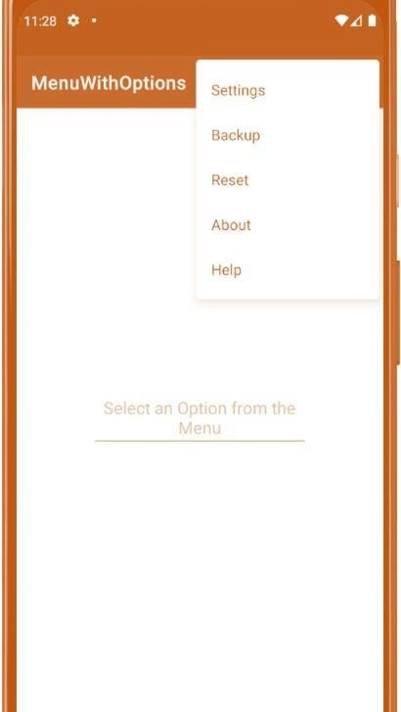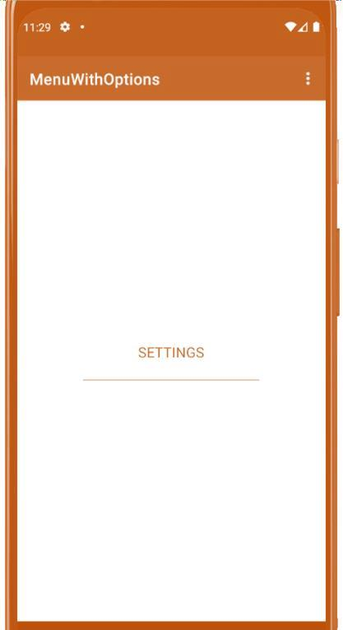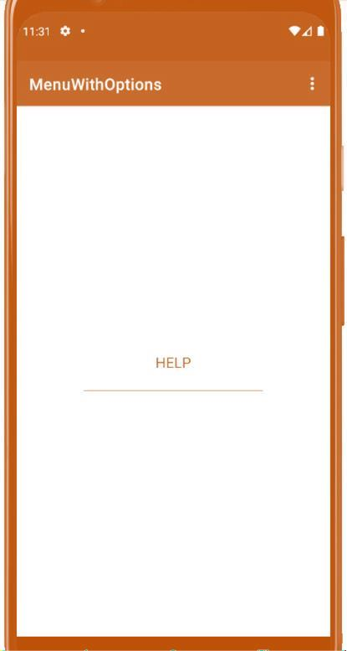

**Practical 7: Create a radio button group with radio button of all courses in your college and on selecting a particular course, teacher-in- charge ofthat course should appear at the bottom of the screen.**

Code:

activity_main.xml

<?xml version="1.0" encoding="utf-8"?>

<androidx.constraintlayout.widget.ConstraintLayout xmlns:andr[oid="ht](http://schemas.android.com/apk/res/android)tp://[schemas.android.com/apk/res/android"](http://schemas.android.com/apk/res/android) xmlns:a[pp="ht](http://schemas.android.com/apk/res-auto)tp:[//](http://schemas.android.com/apk/res-auto)s[chemas.android.com/apk/res-auto"](http://schemas.android.com/apk/res-auto) xmlns:tools[="ht](http://schemas.android.com/tools)t[p://](http://schemas.android.com/tools)s[chemas.android.com/tools](http://schemas.android.com/tools)" android:layout_width="match_parent" android:layout_height="match_parent" tools:context=".MainActivity">

<RelativeLayout android:layout_width="match_parent" android:layout_height="match_parent" android:layout_margin="75dp" app:layout_constraintBottom_toBottomOf="parent" app:layout_constraintLeft_toLeftOf="parent" app:layout_constraintRight_toRightOf="parent" app:layout_constraintTop_toTopOf="parent" >

<RadioGroup android:layout_width="match_parent" android:layout_height="wrap_content" android:id="@+id/rgCourses"

android:layout_centerInParent="true">

</RadioGroup>

</RelativeLayout>

</androidx.constraintlayout.widget.ConstraintLayout>

## MainActivity.java

package com.example.p7;

import androidx.appcompat.app.AppCompatActivity; import android.os.Bundle;

import androidx.appcompat.app.AppCompatActivity; import android.os.Bundle;

import android.provider.MediaStore; import android.widget.RadioGroup; import android.widget.RadioButton;

import com.google.android.material.snackbar.Snackbar; import java.util.HashMap;

public class MainActivity extends AppCompatActivity { private RadioGroup rgCourses;

private HashMap<String, String> coursesMap; @Override

protected void onCreate(Bundle savedInstanceState) { super.onCreate(savedInstanceState); setContentView(R.layout.activity_main); initCourses();

}

private void initCourses(){ rgCourses=(RadioGroup)findViewById(R.id.rgCourses); if (coursesMap==null){

coursesMap=new HashMap<>();

coursesMap.put("BSc(H) Computer Science"," Harsh Meena");

coursesMap.put("BCom(H)"," Tejas Gupta"); coursesMap.put("BA(H) Sociology"," Pandey Sir"); for (String course : coursesMap.keySet()){

RadioButton rButton=new RadioButton(MainActivity.this); rButton.setText(course);

rgCourses.addView(rButton);

}

rgCourses.setOnCheckedChangeListener(new RadioGroup.OnCheckedChangeListener() { @Override

public void onCheckedChanged(RadioGroup group, int checkedId) { int checkedRadioButtonId=rgCourses.getCheckedRadioButtonId();

RadioButton rButton=(RadioButton) findViewById(checkedRadioButtonId); Snackbar.make(rgCourses,coursesMap.get(rButton.getText()),Snackbar.LENGTH_SHORT)

.show();

}

});

}

}

}

OUTPUT –

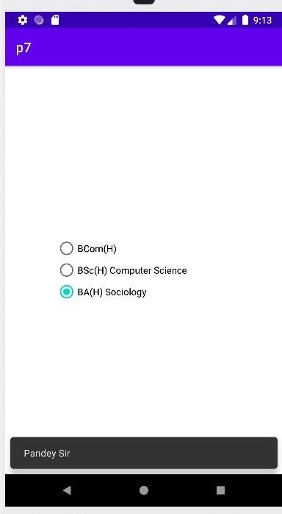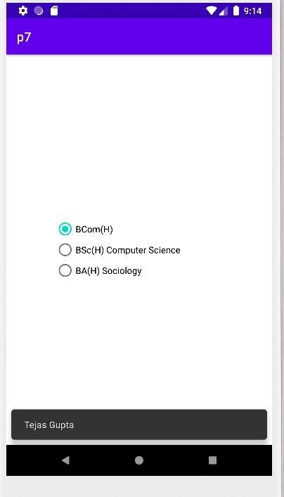

# Practical 8: Create a list of all courses in your college and on selectinga particular course parent department and the teacher-in-charge ofthat department should appear at the bottom of the screen.

Code:

activity_main.xml

<?xml version="1.0" encoding="utf-8"?>

<androidx.constraintlayout.widget.ConstraintLayout xmlns:andr[oid="ht](http://schemas.android.com/apk/res/android)tp://[schemas.android.com/apk/res/android"](http://schemas.android.com/apk/res/android) xmlns:a[pp="ht](http://schemas.android.com/apk/res-auto)tp:[//](http://schemas.android.com/apk/res-auto)s[chemas.android.com/apk/res-auto"](http://schemas.android.com/apk/res-auto) xmlns:tools[="ht](http://schemas.android.com/tools)t[p://](http://schemas.android.com/tools)s[chemas.android.com/tools](http://schemas.android.com/tools)" android:layout_width="match_parent" android:layout_height="match_parent" tools:context=".MainActivity">

<RelativeLayout

android:layout_width="match_parent" android:layout_height="match_parent" android:layout_margin="90dp" app:layout_constraintBottom_toBottomOf="parent" app:layout_constraintLeft_toLeftOf="parent" app:layout_constraintRight_toRightOf="parent" app:layout_constraintTop_toTopOf="parent" >

<RadioGroup android:layout_width="match_parent"

android:layout_height="wrap_content" android:id="@+id/rgCourses" android:layout_centerInParent="true">

</RadioGroup>

</RelativeLayout>

</androidx.constraintlayout.widget.ConstraintLayout>

## MainActivity.java

package com.example.p8;

import androidx.appcompat.app.AppCompatActivity; import android.os.Bundle;

import android.provider.MediaStore; import android.widget.RadioGroup; import android.widget.RadioButton;

import com.google.android.material.snackbar.Snackbar; import java.util.HashMap;

public class MainActivity extends AppCompatActivity { private RadioGroup rgCourses;

private HashMap<String, String> coursesMap; @Override

protected void onCreate(Bundle savedInstanceState) { super.onCreate(savedInstanceState); setContentView(R.layout.activity_main); initCourses();

}

private void initCourses(){ rgCourses=(RadioGroup)findViewById(R.id.rgCourses); if (coursesMap==null){

coursesMap=new HashMap<>();

coursesMap.put("BSc(H) Computer Science","Dept of Computer Sc - Mr. Harsh"); coursesMap.put("BCom(H)","Dept of Commerce - Mr. Tejas"); coursesMap.put("BA(H) Sociology"," Dept of Economics - Mr. Pandey");

for (String course : coursesMap.keySet()){

RadioButton rButton=new RadioButton(MainActivity.this); rButton.setText(course);

rgCourses.addView(rButton);

}

rgCourses.setOnCheckedChangeListener(new RadioGroup.OnCheckedChangeListener() { @Override

public void onCheckedChanged(RadioGroup group, int checkedId) { int checkedRadioButtonId=rgCourses.getCheckedRadioButtonId();

RadioButton rButton=(RadioButton) findViewById(checkedRadioButtonId);

}

});

}

}

}

Snackbar.make(rgCourses,coursesMap.get(rButton.getText()),Snackbar.LENGTH_SHORT)

.show();

OUTPUT –

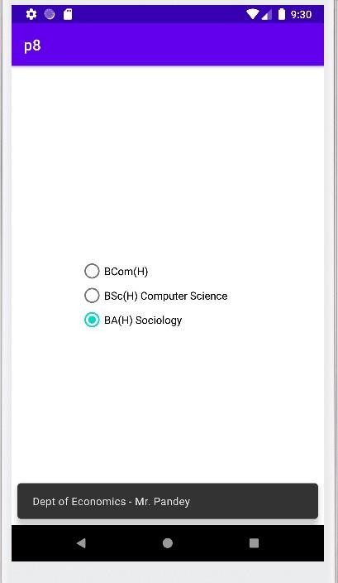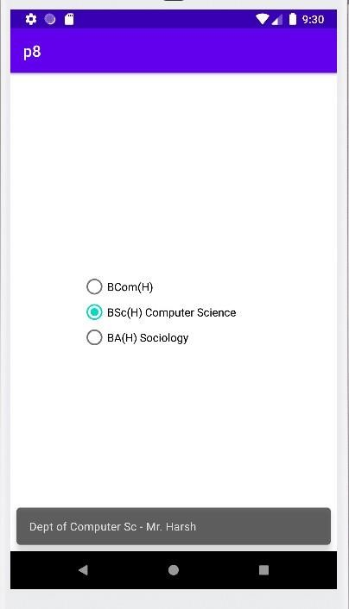

# Practical 9

1. **: Create an application with three buttons (with different colornames) verticallyaligned, on selecting a button color of the screen will change.**

Code:

activity_main.xml

<?xml version="1.0" encoding="utf-8"?>

<androidx.constraintlayout.widget.ConstraintLayout xmlns:andr[oid="ht](http://schemas.android.com/apk/res/android)tp://[schemas.android.com/apk/res/android"](http://schemas.android.com/apk/res/android) xmlns:a[pp="ht](http://schemas.android.com/apk/res-auto)tp:[//](http://schemas.android.com/apk/res-auto)s[chemas.android.com/apk/res-auto"](http://schemas.android.com/apk/res-auto) xmlns:tools[="ht](http://schemas.android.com/tools)t[p://](http://schemas.android.com/tools)s[chemas.android.com/tools](http://schemas.android.com/tools)" android:id="@+id/layoutSuperParent" android:layout_width="match_parent" android:layout_height="match_parent" tools:context=".MainActivity">

<LinearLayout android:layout_width="wrap_content" android:layout_height="wrap_content" android:orientation="vertical" app:layout_constraintBottom_toBottomOf="parent" app:layout_constraintLeft_toLeftOf="parent" app:layout_constraintRight_toRightOf="parent" app:layout_constraintTop_toTopOf="parent">

<Button android:layout_width="150dp" android:layout_height="wrap_content" android:id="@+id/btnRed"

android:layout_gravity="center" android:backgroundTint="@android:color/holo_red_dark" android:text="RED"/>

<Button android:layout_width="150dp" android:layout_height="wrap_content" android:id="@+id/btnBlue" android:layout_gravity="center" android:backgroundTint="@android:color/holo_blue_light" android:text="BLUE"/>

<Button android:layout_width="150dp" android:layout_height="wrap_content" android:id="@+id/btnGreen" android:gravity="center"

android:backgroundTint="@android:color/holo_green_dark" android:text="GREEN"/>

<Button android:layout_width="150dp" android:layout_height="wrap_content" android:id="@+id/btnReset" android:gravity="center" android:text="Reset"/>

</LinearLayout>

</androidx.constraintlayout.widget.ConstraintLayout>

## MainActivity.java

package com.example.p9;

import androidx.appcompat.app.AppCompatActivity; import android.graphics.Color;

import android.view.View; import android.widget.Button;

import androidx.constraintlayout.widget.ConstraintLayout; import android.os.Bundle;

public class MainActivity extends AppCompatActivity implements View.OnClickListener { private Button btnRed;

private Button btnBlue; private Button btnGreen; private Button btnReset;

private ConstraintLayout layoutSuperParent; @Override

protected void onCreate(Bundle savedInstanceState) { super.onCreate(savedInstanceState); setContentView(R.layout.activity_main);

layoutSuperParent=(ConstraintLayout)findViewById(R.id.layoutSuperParent); btnRed=(Button)findViewById(R.id.btnRed); btnBlue=(Button)findViewById(R.id.btnBlue); btnGreen=(Button)findViewById(R.id.btnGreen); btnReset=(Button)findViewById(R.id.btnReset); btnRed.setOnClickListener(this);

btnBlue.setOnClickListener(this); btnGreen.setOnClickListener(this); btnReset.setOnClickListener(this);

}

@Override

public void onClick(View v){ switch (v.getId()){

case R.id.btnRed: layoutSuperParent.setBackgroundColor(Color.RED); break; case R.id.btnBlue: layoutSuperParent.setBackgroundColor(Color.BLUE); break; case R.id.btnGreen: layoutSuperParent.setBackgroundColor(Color.GREEN); break;

case R.id.btnReset: layoutSuperParent.setBackgroundColor(Color.TRANSPARENT); break; default:

break;

}

}

}

OUTPUT –

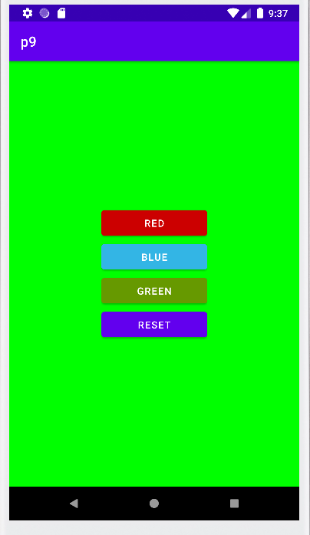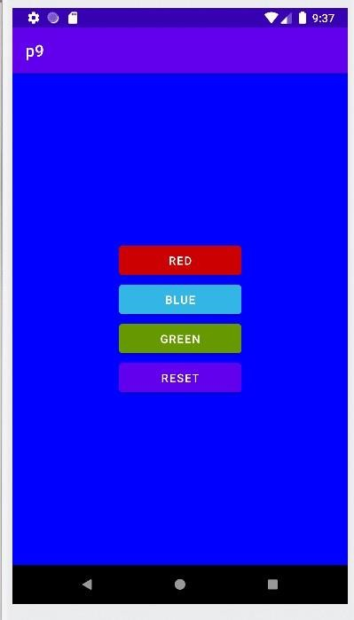

# Practical 9

1. **: Create an application with three buttons (with different colornames) horizontally aligned, on selecting a button color of the screen will change.**

Code:

activity_main.xml

<?xml version="1.0" encoding="utf-8"?>

<androidx.constraintlayout.widget.ConstraintLayout xmlns:andr[oid="ht](http://schemas.android.com/apk/res/android)tp://[schemas.android.com/apk/res/android"](http://schemas.android.com/apk/res/android) xmlns:ap[p="ht](http://schemas.android.com/apk/res-auto)tp:[//schemas.android.com/apk/res-auto"](http://schemas.android.com/apk/res-auto) xmlns:tools[="ht](http://schemas.android.com/tools)t[p://](http://schemas.android.com/tools)s[chemas.android.com/tools](http://schemas.android.com/tools)" android:id="@+id/layoutSuperParent" android:layout_width="match_parent" android:layout_height="match_parent" tools:context=".MainActivity">

<LinearLayout android:layout_width="wrap_content" android:layout_height="wrap_content" android:orientation="horizontal" app:layout_constraintBottom_toBottomOf="parent" app:layout_constraintLeft_toLeftOf="parent" app:layout_constraintRight_toRightOf="parent" app:layout_constraintTop_toTopOf="parent">

<Button android:layout_width="75dp" android:layout_height="wrap_content" android:id="@+id/btnRed"

android:layout_gravity="center" android:backgroundTint="@android:color/holo_red_dark" android:text="RED"/>

<Button android:layout_width="75dp" android:layout_height="wrap_content" android:id="@+id/btnBlue" android:layout_gravity="center" android:backgroundTint="@android:color/holo_blue_light" android:text="BLUE"/>

<Button android:layout_width="75dp" android:layout_height="wrap_content" android:id="@+id/btnGreen" android:gravity="center"

android:backgroundTint="@android:color/holo_green_dark" android:text="GREEN"/>

<Button android:layout_width="75dp" android:layout_height="wrap_content" android:id="@+id/btnReset" android:gravity="center" android:text="Reset"/>

</LinearLayout>

</androidx.constraintlayout.widget.ConstraintLayout>

## MainActivity.java

package com.example.p9;

import androidx.appcompat.app.AppCompatActivity; import android.graphics.Color;

import android.view.View; import android.widget.Button;

import androidx.constraintlayout.widget.ConstraintLayout; import android.os.Bundle;

public class MainActivity extends AppCompatActivity implements View.OnClickListener { private Button btnRed;

private Button btnBlue; private Button btnGreen; private Button btnReset;

private ConstraintLayout layoutSuperParent; @Override

protected void onCreate(Bundle savedInstanceState) { super.onCreate(savedInstanceState); setContentView(R.layout.activity_main);

layoutSuperParent=(ConstraintLayout)findViewById(R.id.layoutSuperParent); btnRed=(Button)findViewById(R.id.btnRed); btnBlue=(Button)findViewById(R.id.btnBlue); btnGreen=(Button)findViewById(R.id.btnGreen); btnReset=(Button)findViewById(R.id.btnReset); btnRed.setOnClickListener(this);

btnBlue.setOnClickListener(this); btnGreen.setOnClickListener(this); btnReset.setOnClickListener(this);

}

@Override

public void onClick(View v){ switch (v.getId()){

case R.id.btnRed: layoutSuperParent.setBackgroundColor(Color.RED); break; case R.id.btnBlue: layoutSuperParent.setBackgroundColor(Color.BLUE); break; case R.id.btnGreen: layoutSuperParent.setBackgroundColor(Color.GREEN); break;

case R.id.btnReset: layoutSuperParent.setBackgroundColor(Color.TRANSPARENT); break; default:

break;

}

}

}

OUTPUT –

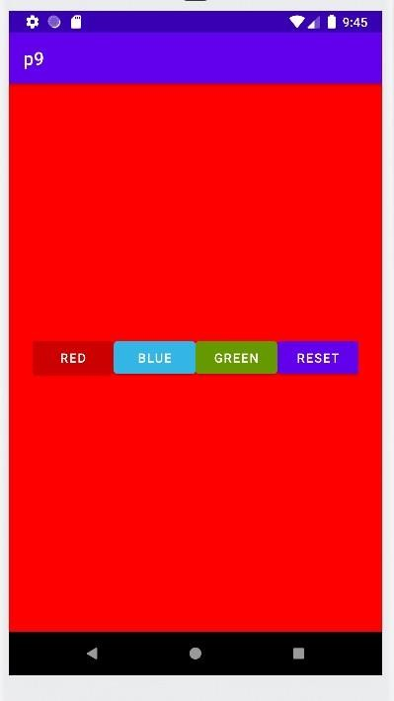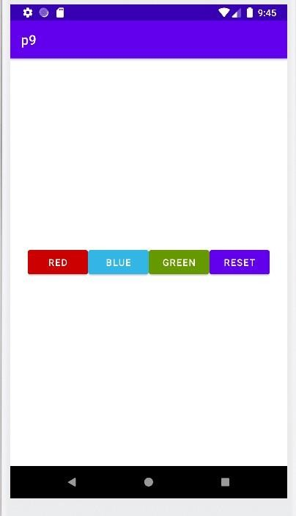

# Practical 10: Create a Login application (check username and password). Onsuccessful login, pop up the message. ("Welcome username")

**Code:**

# activity_main.xml

<?xml version="1.0" encoding="utf-8"?>

<androidx.constraintlayout.widget.ConstraintLayout xmlns:andr[oid="ht](http://schemas.android.com/apk/res/android)tp://[schemas.android.com/apk/res/android"](http://schemas.android.com/apk/res/android) xmlns:a[pp="ht](http://schemas.android.com/apk/res-auto)tp:[//](http://schemas.android.com/apk/res-auto)s[chemas.android.com/apk/res-auto"](http://schemas.android.com/apk/res-auto) xmlns:tools[="ht](http://schemas.android.com/tools)t[p://](http://schemas.android.com/tools)s[chemas.android.com/tools](http://schemas.android.com/tools)" android:layout_width="match_parent" android:layout_height="match_parent" tools:context=".MainActivity">

<EditText android:id="@+id/etEmail"

android:layout_width="wrap_content" android:layout_height="wrap_content" android:layout_marginTop="240dp" android:autofillHints="false" android:ems="10" android:hint="@string/e_mail_id" android:inputType="textEmailAddress"

app:layout_constraintBottom_toTopOf="@id/etPassword" app:layout_constraintEnd_toEndOf="parent" app:layout_constraintStart_toStartOf="parent" app:layout_constraintTop_toTopOf="parent" />

<EditText android:id="@+id/etPassword" android:layout_width="wrap_content"

android:layout_height="wrap_content" android:layout_marginTop="10dp" android:autofillHints="false" android:ems="10" android:hint="@string/password" android:inputType="textPassword"

app:layout_constraintBottom_toTopOf="@id/btnLogin" app:layout_constraintEnd_toEndOf="parent" app:layout_constraintStart_toStartOf="parent" app:layout_constraintTop_toBottomOf="@id/etEmail" />

<Button android:id="@+id/btnLogin"

android:layout_width="wrap_content" android:layout_height="wrap_content" android:layout_marginTop="30dp" android:text="@string/login" app:layout_constraintBottom_toTopOf="@id/btnRegister" app:layout_constraintEnd_toEndOf="parent" app:layout_constraintStart_toStartOf="parent" app:layout_constraintTop_toBottomOf="@id/etPassword" />

<Button

android:id="@+id/btnRegister" android:layout_width="wrap_content" android:layout_height="wrap_content" android:layout_marginBottom="250dp" android:text="@string/register" app:layout_constraintBottom_toBottomOf="parent" app:layout_constraintEnd_toEndOf="parent" app:layout_constraintStart_toStartOf="parent" app:layout_constraintTop_toBottomOf="@id/btnLogin" />

</androidx.constraintlayout.widget.ConstraintLayout>

# MainActivity.java

package com.example.prac10;

import android.database.sqlite.SQLiteConstraintException; import android.os.Bundle;

import android.util.Log; import android.widget.Button;

import android.widget.EditText; import android.widget.Toast;

import androidx.appcompat.app.AppCompatActivity;

import com.example.prac10.models.User;

import com.example.prac10.services.UserService;

public class MainActivity extends AppCompatActivity { private EditText etEmail;

private EditText etPassword; private Button btnLogin; private Button btnRegister; private UserService userService;

@Override

protected void onCreate(Bundle savedInstanceState) { super.onCreate(savedInstanceState); setContentView(R.layout.activity_main);

userService = UserService.getInstance(); UserService.initDatabase(this);

etEmail = (EditText) findViewById(R.id.etEmail); etPassword = (EditText) findViewById(R.id.etPassword); btnLogin = (Button) findViewById(R.id.btnLogin); btnRegister = (Button) findViewById(R.id.btnRegister);

btnLogin.setOnClickListener(v -> { User user = validateCredentials(); if (user != null) {

try {

userService.login(user);

Toast.makeText(this, "Welcome " + userService.getUser().email, Toast.LENGTH_SHORT).show();

} catch (IllegalStateException illegalStateException) {

Toast.makeText(this, "Invalid E-mail/Password", Toast.LENGTH_SHORT).show();

} catch (Exception e) { Log.d("TAG", e.getMessage());

Toast.makeText(this, "Error", Toast.LENGTH_SHORT).show();

}

}

});

btnRegister.setOnClickListener(v -> { User user = validateCredentials(); if (user != null) {

try {

userService.register(user);

Toast.makeText(this, "Registered", Toast.LENGTH_SHORT).show();

} catch (SQLiteConstraintException sqLiteConstraintException) { Toast.makeText(this, "E-mail Already Used", Toast.LENGTH_SHORT).show();

} catch (Exception e) {

Toast.makeText(this, "Error", Toast.LENGTH_SHORT).show();

}

}

});

}

private User validateCredentials() {

String email = etEmail.getText().toString().trim();

String password = etPassword.getText().toString().trim();

if (email.length() == 0) {

etEmail.setError("Enter your e-mail address"); return null;

}

if (password.length() == 0) { etPassword.setError("Enter your password"); return null;

}

return new User(email, password);

}

}

# OUTPUT –

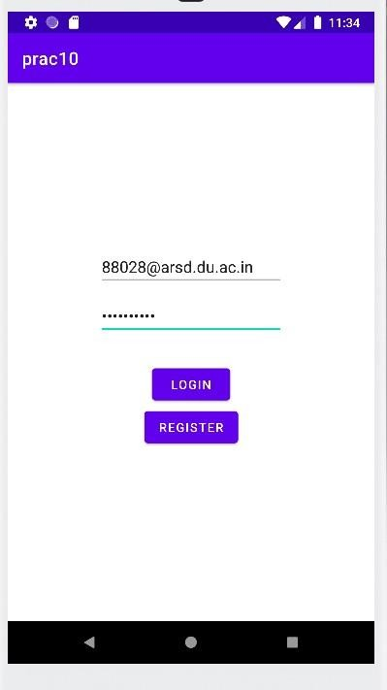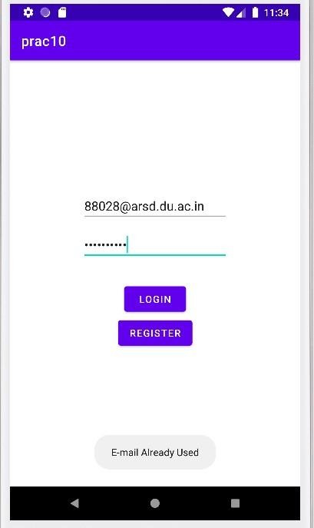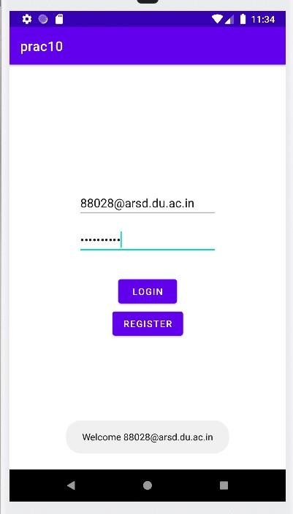

**Practical 11: Create a login application as above, on successful login redirect to another activity with logout button. On click of logout button a dialog appears with OK and CANCEL button. On OK button clickgo to login activity and onCANCEL stay at same activity.**

**Code:**

**activity_main.xml**

<?*xml version*="1.0" *encoding*="utf-8"?>

<androidx.constraintlayout.widget.ConstraintLayout *xmlns:android*[="ht](http://schemas.android.com/apk/res/android)tp[://schemas.android.com/apk/res/android"](http://schemas.android.com/apk/res/android) *xmlns:app*[="ht](http://schemas.android.com/apk/res-auto)t[p://](http://schemas.android.com/apk/res-auto)s[chemas.android.com/apk/res-auto"](http://schemas.android.com/apk/res-auto) *xmlns:tools*[="ht](http://schemas.android.com/tools)t[p:](http://schemas.android.com/tools)/[/schemas.android.com/tools](http://schemas.android.com/tools)" *android:layout_width*="match_parent" *android:layout_height*="match_parent" *tools:context*=".MainActivity">

<EditText

*android:id*="@+id/etEmail" *android:layout_width*="wrap_content" *android:layout_height*="wrap_content" *android:layout_marginTop*="240dp" *android:autofillHints*="false" *android:ems*="10" *android:hint*="@string/e_mail_id" *android:inputType*="textEmailAddress"

*app:layout_constraintBottom_toTopOf*="@id/etPassword" *app:layout_constraintEnd_toEndOf*="parent" *app:layout_constraintStart_toStartOf*="parent" *app:layout_constraintTop_toTopOf*="parent" />

<EditText *android:id*="@+id/etPassword" *android:layout_width*="wrap_content"

*android:layout_height*="wrap_content" *android:layout_marginTop*="10dp" *android:autofillHints*="false" *android:ems*="10"

*android:hint*="@string/password" *android:inputType*="textPassword" *app:layout_constraintBottom_toTopOf*="@id/btnLogin" *app:layout_constraintEnd_toEndOf*="parent" *app:layout_constraintStart_toStartOf*="parent" *app:layout_constraintTop_toBottomOf*="@id/etEmail" />

<Button

*android:id*="@+id/btnLogin" *android:layout_width*="wrap_content" *android:layout_height*="wrap_content" *android:layout_marginTop*="30dp" *android:text*="@string/login" *app:layout_constraintBottom_toTopOf*="@id/btnRegister" *app:layout_constraintEnd_toEndOf*="parent" *app:layout_constraintStart_toStartOf*="parent" *app:layout_constraintTop_toBottomOf*="@id/etPassword" />

<Button

*android:id*="@+id/btnRegister" *android:layout_width*="wrap_content" *android:layout_height*="wrap_content" *android:layout_marginBottom*="250dp" *android:text*="@string/register" *app:layout_constraintBottom_toBottomOf*="parent" *app:layout_constraintEnd_toEndOf*="parent" *app:layout_constraintStart_toStartOf*="parent" *app:layout_constraintTop_toBottomOf*="@id/btnLogin" />

</androidx.constraintlayout.widget.ConstraintLayout>

# Activity_member_module.xml

<?xml version="1.0" encoding="utf-8"?>

<androidx.constraintlayout.widget.ConstraintLayout xmlns:andr[oid="ht](http://schemas.android.com/apk/res/android)tp://[schemas.android.com/apk/res/android"](http://schemas.android.com/apk/res/android) xmlns:a[pp="ht](http://schemas.android.com/apk/res-auto)tp:[//](http://schemas.android.com/apk/res-auto)s[chemas.android.com/apk/res-auto"](http://schemas.android.com/apk/res-auto) xmlns:tools[="ht](http://schemas.android.com/tools)t[p://](http://schemas.android.com/tools)s[chemas.android.com/tools](http://schemas.android.com/tools)"

android:layout_width="match_parent" android:layout_height="match_parent" tools:context=".MemberModule">

<TextView android:id="@+id/tvWelcome" android:layout_width="wrap_content" android:layout_height="wrap_content" android:text="@string/welcome"

android:textAppearance="@style/TextAppearance.AppCompat.Display1" app:layout_constraintBottom_toTopOf="@id/tvEmail" app:layout_constraintEnd_toEndOf="parent" app:layout_constraintStart_toStartOf="parent" app:layout_constraintTop_toTopOf="parent" />

<TextView android:id="@+id/tvEmail"

android:layout_width="wrap_content" android:layout_height="wrap_content" android:text=""

app:layout_constraintBottom_toTopOf="@id/btnLogout" app:layout_constraintEnd_toEndOf="parent" app:layout_constraintStart_toStartOf="parent" app:layout_constraintTop_toBottomOf="@id/tvWelcome" />

<Button android:id="@+id/btnLogout"

android:layout_width="wrap_content" android:layout_height="wrap_content" android:text="@string/log_out" app:layout_constraintBottom_toBottomOf="parent" app:layout_constraintEnd_toEndOf="parent" app:layout_constraintStart_toStartOf="parent" app:layout_constraintTop_toBottomOf="@+id/tvEmail" />

</androidx.constraintlayout.widget.ConstraintLayout>

# MainActivity.java

*package* com.example.prac11;

*import* android.content.Intent;

*import* android.database.sqlite.SQLiteConstraintException;

*import* android.os.Bundle; *import* android.util.Log; *import* android.widget.Button;

*import* android.widget.EditText; *import* android.widget.Toast;

*import* androidx.appcompat.app.AppCompatActivity; *import* com.example.prac11.models.User;

*import* com.example.prac11.services.UserService;

*public class* MainActivity *extends* AppCompatActivity {

*private* EditText etEmail; *private* EditText etPassword; *private* Button btnLogin; *private* Button btnRegister; *private* UserService userService;

@Override

*protected void* onCreate(Bundle savedInstanceState) { *super*.onCreate(savedInstanceState); setContentView(R.layout.*activity_main*);

userService = UserService.*getInstance*(); UserService.*initDatabase*(*this*);

etEmail = (EditText) findViewById(R.id.*etEmail*); etPassword = (EditText) findViewById(R.id.*etPassword*); btnLogin = (Button) findViewById(R.id.*btnLogin*); btnRegister = (Button) findViewById(R.id.*btnRegister*);

btnLogin.setOnClickListener(v -> { User user = validateCredentials(); *if* (user != *null*) {

*try* {

userService.login(user);

Toast.*makeText*(*this*, "Logged In", Toast.*LENGTH_SHORT*).show(); startActivity(*new* Intent(*this*, MemberModule.*class*));

} *catch* (IllegalStateException illegalStateException) {

Toast.*makeText*(*this*, "Invalid E-mail/Password", Toast.*LENGTH_SHORT*).show();

} *catch* (Exception e) {

Log.*d*("TAG", e.getMessage());

Toast.*makeText*(*this*, "Error", Toast.*LENGTH_SHORT*).show();

}

}

});

btnRegister.setOnClickListener(v -> { User user = validateCredentials(); *if* (user != *null*) {

*try* {

userService.register(user);

Toast.*makeText*(*this*, "Registered", Toast.*LENGTH_SHORT*).show(); startActivity(*new* Intent(*this*, MemberModule.*class*));

} *catch* (SQLiteConstraintException sqLiteConstraintException) { Toast.*makeText*(*this*, "E-mail Already Used", Toast.*LENGTH_SHORT*).show();

} *catch* (Exception e) {

Toast.*makeText*(*this*, "Error", Toast.*LENGTH_SHORT*).show();

}

}

});

}

*private* User validateCredentials() {

String email = etEmail.getText().toString().trim();

String password = etPassword.getText().toString().trim();

*if* (email.length() == 0) {

etEmail.setError("Enter your e-mail address");

*return null*;

}

*if* (password.length() == 0) { etPassword.setError("Enter your password"); *return null*;

}

*return new* User(email, password);

}

}

# MemberModule.java

*package* com.example.prac11;

*import* android.app.AlertDialog; *import* android.os.Bundle; *import* android.widget.TextView; *import* android.widget.Toast;

*import* androidx.appcompat.app.AppCompatActivity; *import* com.example.prac11.models.User;

*import* com.example.prac11.services.UserService;

*public class* MemberModule *extends* AppCompatActivity {

*private* User user;

*private* UserService userService; *private* TextView tvEmail; *private* TextView btnLogout;

@Override

*protected void* onCreate(Bundle savedInstanceState) { *super*.onCreate(savedInstanceState); setContentView(R.layout.*activity_member_module*);

userService = UserService.*getInstance*(); user = userService.getUser();

tvEmail = (TextView) findViewById(R.id.*tvEmail*); btnLogout = (TextView) findViewById(R.id.*btnLogout*);

*if* (user == *null*) {

*super*.finish();

} *else* {

tvEmail.setText(user.email);

}

btnLogout.setOnClickListener(v -> {

*new* AlertDialog.Builder(*this*)

.setTitle("Logout")

.setMessage("Are you sure you want to log out?")

});

}

.setPositiveButton(android.R.string.*ok*, (dialog, which) -> logoutUser())

.setNegativeButton(android.R.string.*cancel*, *null*)

.setIcon(android.R.drawable.*ic_dialog_alert*)

.show();

*private void* logoutUser() { userService.logout();

Toast.*makeText*(*this*, "Logged Out", Toast.*LENGTH_SHORT*).show();

*super*.finish();

}

}

# OUTPUT –

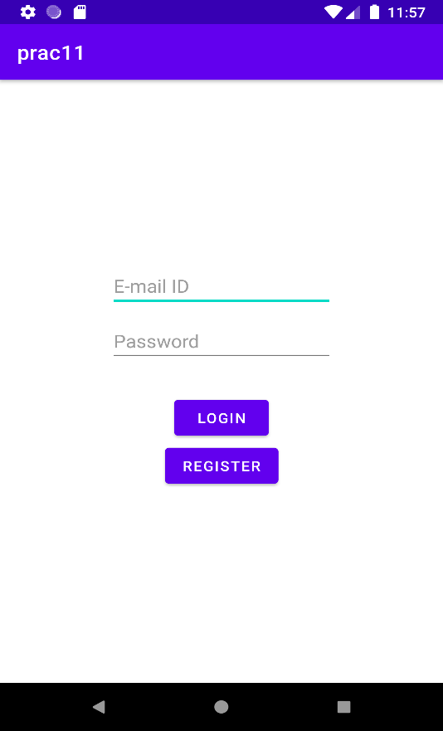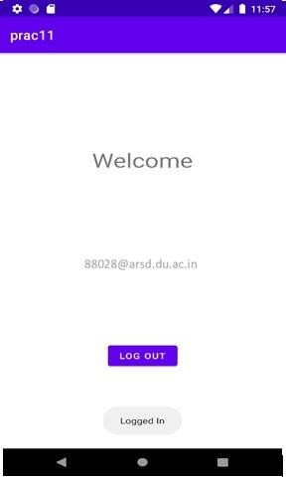

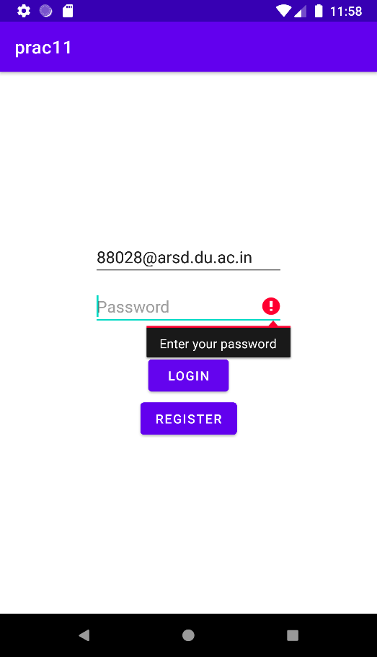

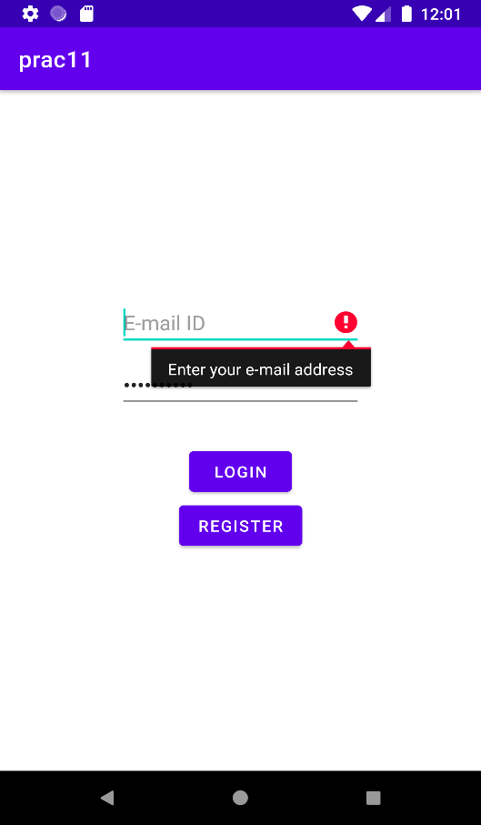

# Practical 12: Create an application to Create, Insert, update andDelete operation on the database.

**Code:**

# activity_main.xml

<?xml version="1.0" encoding="utf-8"?>

<androidx.constraintlayout.widget.ConstraintLayout xmlns:andr[oid="ht](http://schemas.android.com/apk/res/android)tp://[schemas.android.com/apk/res/android"](http://schemas.android.com/apk/res/android) xmlns:a[pp="ht](http://schemas.android.com/apk/res-auto)tp:[//](http://schemas.android.com/apk/res-auto)s[chemas.android.com/apk/res-auto"](http://schemas.android.com/apk/res-auto) xmlns:tools[="ht](http://schemas.android.com/tools)t[p://](http://schemas.android.com/tools)s[chemas.android.com/tools](http://schemas.android.com/tools)" android:id="@+id/clRoot" android:layout_width="match_parent"

android:layout_height="match_parent" tools:context=".MainActivity">

<androidx.swiperefreshlayout.widget.SwipeRefreshLayout android:layout_width="match_parent" android:layout_height="match_parent" android:id="@+id/swipeLayout" app:layout_constraintBottom_toBottomOf="parent" app:layout_constraintLeft_toLeftOf="parent" app:layout_constraintRight_toRightOf="parent" app:layout_constraintTop_toTopOf="parent">

<androidx.recyclerview.widget.RecyclerView android:id="@+id/rvTodos" android:layout_width="wrap_content" android:layout_height="wrap_content" />

</androidx.swiperefreshlayout.widget.SwipeRefreshLayout>

<com.google.android.material.floatingactionbutton.FloatingActionButton android:id="@+id/fabAdd"

android:layout_width="wrap_content" android:layout_height="wrap_content" android:layout_gravity="end|bottom" android:layout_margin="16dp" android:src="@drawable/ic_add" app:layout_constraintBottom_toBottomOf="parent" app:layout_constraintEnd_toEndOf="parent" />

</androidx.constraintlayout.widget.ConstraintLayout>

# Todo_item.xml

<?xml version="1.0" encoding="utf-8"?>

<com.google.android.material.card.MaterialCardView xmlns:andr[oid="ht](http://schemas.android.com/apk/res/android)tp://[schemas.android.com/apk/res/android"](http://schemas.android.com/apk/res/android) xmlns:a[pp="ht](http://schemas.android.com/apk/res-auto)tp:[//](http://schemas.android.com/apk/res-auto)s[chemas.android.com/apk/res-auto"](http://schemas.android.com/apk/res-auto) android:id="@+id/cvParent" android:layout_width="match_parent" android:layout_height="wrap_content" android:layout_marginHorizontal="@dimen/card_margin" android:layout_marginTop="@dimen/card_margin" app:cardCornerRadius="@dimen/cardview_default_radius" app:cardElevation="@dimen/cardview_default_elevation">

<RelativeLayout android:layout_width="match_parent" android:layout_height="wrap_content"

android:layout_margin="@dimen/default_card_content_margin">

<TextView android:id="@+id/tvTodoId"

android:layout_width="wrap_content" android:layout_height="wrap_content" android:visibility="invisible" />

<TextView android:id="@+id/tvTodoContent"

style="@style/TextAppearance.MaterialComponents.Headline6" android:layout_width="wrap_content" android:layout_height="wrap_content" android:text="@string/default_todo_content" />

<TextView android:id="@+id/tvTodoAddedAt" android:layout_width="match_parent" android:layout_height="wrap_content"

android:layout_below="@id/tvTodoContent" android:layout_marginVertical="5dp" android:text="@string/default_todo_added_at" />

<LinearLayout android:layout_width="wrap_content" android:layout_height="wrap_content" android:layout_below="@id/tvTodoAddedAt" android:orientation="horizontal">

<Button android:id="@+id/btnTodoAction"

style="@style/Widget.MaterialComponents.Button.OutlinedButton" android:layout_width="wrap_content" android:layout_height="wrap_content" android:text="@string/default_todo_action" />

<Button android:id="@+id/btnTodoDelete"

style="@style/Widget.MaterialComponents.Button.OutlinedButton" android:textColor="@android:color/holo_red_dark" android:layout_marginStart="10dp" android:layout_width="wrap_content" android:layout_height="wrap_content" android:text="@string/default_todo_delete" />

</LinearLayout>

</RelativeLayout>

</com.google.android.material.card.MaterialCardView>

# Dialog_layout.xml

<?xml version="1.0" encoding="utf-8"?>

<LinearLayout xmlns:andr[oid="ht](http://schemas.android.com/apk/res/android)tp://[schemas.android.com/apk/res/android"](http://schemas.android.com/apk/res/android) android:orientation="vertical"

android:paddingHorizontal="20dp" android:layout_width="match_parent" android:layout_height="match_parent">

<EditText android:id="@+id/etNewContent" android:inputType="text" android:layout_width="match_parent" android:layout_height="wrap_content" android:hint="Content" />

</LinearLayout>

# MainActivity.java

*package* com.example.prac12;

*import* android.app.AlertDialog; *import* android.os.Bundle;

*import* android.view.LayoutInflater; *import* android.view.View;

*import* android.widget.EditText; *import* android.widget.Toast;

*import* androidx.appcompat.app.AppCompatActivity; *import* androidx.recyclerview.widget.LinearLayoutManager; *import* androidx.recyclerview.widget.RecyclerView;

*import* androidx.swiperefreshlayout.widget.SwipeRefreshLayout;

*import* com.google.android.material.floatingactionbutton.FloatingActionButton; *import* com.example.prac12.adapters.RVAdapter;

*import* com.example.prac12.repos.TodoRepository;

*public class* MainActivity *extends* AppCompatActivity *implements*

SwipeRefreshLayout.*OnRefreshListener* { *private* TodoRepository todoRepository; *private* RecyclerView rvTodos;

*private* RVAdapter todosAdapter;

*private* SwipeRefreshLayout swipeLayout;

@Override

*protected void* onCreate(Bundle savedInstanceState) { *super*.onCreate(savedInstanceState); setContentView(R.layout.*activity_main*);

todoRepository = *new* TodoRepository(*this*); todosAdapter = *new* RVAdapter(*this*, todoRepository);

swipeLayout = (SwipeRefreshLayout) findViewById(R.id.*swipeLayout*);

swipeLayout.setOnRefreshListener(*this*);

rvTodos = (RecyclerView) findViewById(R.id.*rvTodos*); rvTodos.setAdapter(todosAdapter); rvTodos.setLayoutManager(*new* LinearLayoutManager(*this*));

FloatingActionButton fabAdd = (FloatingActionButton) findViewById(R.id.*fabAdd*); fabAdd.setOnClickListener(v -> {

View layout = getLayoutInflater().inflate(R.layout.*dialog_layout*, *null*); EditText etNewContent = (EditText) layout.findViewById(R.id.*etNewContent*); AlertDialog dialog = *new* AlertDialog.Builder(*this*)

.setView(layout)

.setTitle("Add New Todo")

.setPositiveButton("Save", (_dialog, which) -> {

String content = etNewContent.getText().toString().trim();

*if* (content.length() == 0) {

Toast.*makeText*(*this*, "No Text Entered", Toast.*LENGTH_SHORT*).show();

} *else* {

todoRepository.create(content); loadTodos();

}

})

});

.setNegativeButton("Cancel", (_dialog, which) -> _dialog.dismiss())

.create(); dialog.show();

loadTodos();

}

@Override

*public void* onRefresh() { loadTodos();

}

*private void* loadTodos() { swipeLayout.setRefreshing(*true*); todosAdapter.setTodos(todoRepository.getAll()); swipeLayout.setRefreshing(*false*);

}

}

# OUTPUT –

